|  |  |
| --- | --- |
| JoyntWay  *Share the ride. Save the planet.* | Abstract  A ridesharing application that aims to revolutionize local transportation by fostering a sense of community and sustainability.    Allyson Bernard, Sai Deepshikha Ganesh, Thi Quynh Ha, Noopura Vaidya  MIS 500 Team 2 |

Table of Contents

Executive Summary: 2

Objective: 3

Purpose: 3

Description: 3

The innovation introduced in this project: 3

Requirements 3

Expected Benefits: 5

Funds: 6

Deliverables: 6

Acceptance Criteria: 6

Milestone Schedule: 6

Key Assumptions: 7

Constraints & Dependencies 7

Major Risks: 8

Validation and Verification Methods 9

Project Manager: Sai Priyanka 9

Main Features of JoyntWay Application 9

Voice Prompt Features 10

Reduce Carbon Footprint 11

Social responsibility and community well-being 11

Feasibility Analysis 12

Marketing Strategy 13

Risk Assessment Matrix 15

Future Recommendations 15

Appendices: 20

## Executive Summary:

JoyntWay is an app that aims to revolutionize local transportation by fostering a sense of community and sustainability by facilitating rideshares. With the increasing need for efficient and eco-friendly travel solutions, our platform serves as a connecting bridge for individuals traveling in the same direction or to similar destinations. Not only does this product provide a needed service for consumers by providing easy access to transportation, cost-sharing calculations, and safety features, but this product will have a big impact on individual’s carbon footprint.

The JoyntWay app shall be developed within a $350,000 budget and is expected to break even in its fourth year of operation with an **ROI of nearly 11%**. Currently, our main revenue driver is through service fees and subscriptions services. In future years we expect to increase revenue with in-app advertisements and are currently collaborating with some globally recognized brands to develop partnerships for this revenue stream.

With 15 million college students in the U.S. alone, JoyntWay is poised to grow in the rideshare market with a product that uniquely benefits drivers and passengers. Our targeted marketing strategy to connect with campus and employer ambassadors, social influencers, and community groups will help our user base grow. We are excited to invite you to invest in JoyntWay and... ***Share the ride. Save the planet***.

## Objective:

The JoyntWay App will be developed within a budget of $350,000 and available for users to connect and find carpooling options by September 30, 2024.

## Purpose:

A ridesharing or carpooling app that aims to revolutionize local transportation by fostering a sense of community and sustainability. With the increasing need for efficient and eco-friendly travel solutions, our platform serves as a connecting bridge for individuals traveling in the same direction or to similar destinations.

## Description:

JoyntWay is a community ride sharing application that focuses on connecting people who live in the same neighborhood, town or work/study in the same school or company and have similar preferences in traveling. Users can use the application to find or offer rides to their community for various purposes and it allows them to split the cost of gas and other travel expenses. Our applications aim to verify the identity and address of the users to ensure safety and trust. Apart from this, the app also helps the users to look at their carbon footprints.

## The innovation introduced in this project:

The community ride sharing application allows the drivers and passengers to negotiate the price and share the cost of the trip, which distinguishes the application from the existing applications on the market. This application also focuses on encouraging friendly and positive social interaction within the community and environmental sustainability among its users.

Competitors: Uber, Lyft

To enhance collaboration between community and JoyntWay users, social media integration can help users connect their ride sharing profiles with their social media accounts like Facebook. Instagram, etc. By using other social media platforms, users can easily find and connect with other users that share the same interests, preferences, or destinations. It also helps drivers announce their upcoming trips. Doing so, users can self-select their riding group via social media group integration rather than riding with strangers. Users can also share their ride stories, photos, reviews with friends, family and even developers for a better experience.

## Requirements

### Business Requirement

This community-based rideshare app will allow users within a given social or work group to join and carpool to shared destinations. Users want to feel safe and connected during their regular commute. In addition to caring about the environment, many populations around attending college or working at an internship have a need for temporary, regular transportation. For people in this situation, it is not sustainable to purchase, insure, and register a vehicle of their own. This population needs a better alternative to current rideshare services, taxis, biking, or walking. Many areas in the U.S. are not pedestrian or cyclist friendly. Users need to feel connected to the others in their carpool to be fully engaged in their community and comfortable riding with strangers. Both drivers and passengers will benefit from their partnership by sharing costs and making the commute more friendly. The ancillary costs of vehicle ownership vary by state and excessive costs can be a barrier to ownership and maintenance, especially to those of lesser means. This community based rideshare app will be evaluated by the number of users that sign up, percentage of users that convert to taking more than 3 rides, and the percentage that complete regular rides on a set schedule.

### User Requirements

Drivers:

This application will enable drivers to be fairly compensated for the efforts and additional wear and tear to their vehicle to commute with other riders.

This application will give drivers recommendations on the best routes, accounting for traffic and pick-up locations of different passengers.

This application will allow drivers to accept or decline passengers for one off pick-up and a carpool routine.

Passengers:

This application will allow passengers to preschedule their drivers for singular events or set up a reoccurring carpool for consistent transportation so they can get to know others in their community with a similar interest in activities.

The application will enable passengers to know how the price of each ride is calculated and provide a trusted 3rd party platform to manage payments.

The application will provide security to the passengers’ data and personal wellbeing with an enhanced community focus.

### Functional Requirements

Driver Functionality:

* The system will handle the driver registration and community membership.
* The system will enable earnings tracking and reporting.
* The system will show ride requests with passenger and route details.
* The system will handle cancellation requests.
* The system will provide a fare splitting option for passengers.
* The system will provide built-in geolocation services for navigation.
* The system will announce promotion and referral code support.
* The system will calculate and highlight the driver’s carbon footprint impact.

Passenger Functionality:

* The system will enable user registration and community membership.
* The system will connect the drivers and ride requests.
* The system will enable the rating and review system.
* The system will process users’ payment.
* The system will process, and update ride details based on real-time projections.
* The system will provide an overview of drivers available by type (e.g. quiet car, EV, specific community).
* The system will provide multiple language support.
* The system will use a device’s existing microphone and speakers to allow voice commands and prompts.
* The system will calculate and highlight the passenger’s carbon footprint impact.

### Non-Functional Requirements

Performance:

* This application should load quickly and respond promptly to user inputs.
* This application should efficiently manage a high volume of concurrent users.
* The application should efficiently process GPS and payment requests.

Reliability:

* The application should operate continuously with minimal downtime.
* The application should have regular system upgrades and maintenance checks.

Security:

* The system should ensure data integrity and reliability.
* The system should protect user data and payment information.
* The system should implement robust authentication and authorization measures.
* The system should establish comprehensive data backup and recovery procedures.

Usability:

* The system should provide a user-friendly interface across all platforms.
* The system should offer clear and intuitive navigation for users.
* The system will be compatible with accessible screen reader services.

## Expected Benefits:

**Convenience for Users:**

Soft Benefits: Users can easily request rides, track drivers, and pay electronically or through the wallet, community involvement, time saving, environment friendly and reducing the stress of finding transportation.

Dollar Benefits: Users can potentially save money by avoiding the costs associated with owning and maintaining a personal vehicle, such as fuel, insurance, parking, and maintenance.

* Fuel: This could range from $500 to $3,000 or more annually, depending on how much they typically drive.
* Insurance: On average, car insurance costs in the United States can range from $1,000 to $2,000 per year. By using a ride-sharing app, users may save this amount.
* Parking: In urban areas, monthly parking fees can range from $100 to $500 or more. Users in these areas can save a substantial amount annually.
* Maintenance: Depending on the age and condition of their vehicle, users could save $500 to $1,500 or more annually.

**Accessibility:**

Soft Benefits: Ride-sharing services increase transportation options, making it easier for people, especially those with limited mobility, to access transportation. It also has an option to choose multiple languages for support and voice prompts for easy use.

Dollar Benefits: Reduced need for personal car ownership can lead to savings on vehicle-related expenses. The potential annual savings from not owning a car can range from $3,000 to $7,000 or more, depending on individual circumstances and location.

**Profit for Drivers:**

Soft Benefits: Drivers have the benefit of cost-cutting on their daily gas expenses. They also get a chance to connect with people within the community and have a sense of content by providing a sustainable solution.

Dollar Benefits: Drivers can save on gas money required for their daily travel and also can earn a minimal extra income based on the number of rides they provide, helping them supplement their earnings or make it a full-time job.

**Reduced Congestion and Pollution:**

Soft Benefits: Ridesharing can help create a cleaner and less congested environment by lowering carbon emissions and traffic congestion. App generates a carbon footprint report for each driver and passenger, making them aware of their contribution to the environment.

Dollar Benefits: Cities could save money on infrastructure upkeep and medical expenses tied to pollution-related illnesses.

**Data Analyzation:**

Soft Benefits: Our businesses can gather and analyze data to enhance services like optimizing operations, data insights to further reduce carbon footprint contributing to sustainable growth, route optimization, wait time reduction, enhancing overall effectiveness of cost-sharing metrics, and more availability of rides.

Dollar Benefits: Increased productivity can result in cost savings and higher income for the company.

**Economic Expansion:**

Soft Benefits: Boosting the local economy by shared expenses. Shared rides contribute to cost savings for users, and the money saved can be reinvested in local businesses, supporting the economic growth of the community.

Dollar Benefits: $1,000 injected into local businesses annually due to redirected expenses. User’s frequent small businesses along shared routes, providing a significant boost to these establishments and encouraging entrepreneurship within the community. $100,000 increase in local tourism revenue due to improved accessibility. Greater economic activity may result in larger tax collections for the government.

## Funds:

$350,000 from Mr. Mark Cuban, a well-known investor passionate about sustainable and community-oriented solutions.

## Deliverables:

Deliverable 1 (1/31/24): Develop a functional beta version of an app that includes the features listed in Appendix A.

Deliverable 2 (3/31/24): Perform extensive user acceptance testing to ensure product functionality.

Deliverable 3 (9/30/24): Publish a market-ready version of the application on the Apple and GooglePlay stores.

## Acceptance Criteria:

1. The app should contain all four of the major features listed in Appendix A so that testing can begin.
2. User acceptance testing should last at least 6 months with each of the features to ensure that the product is performing as expected.
3. The app will be approved for purchase in the Apple and GooglePlay stores.

## Milestone Schedule:

Month 1: Define research problems, identify target audiences, gather requirements to inform the decision-making process. Create Storyboard and low-profile prototype, wireframe.

Month 2: Research Design and High-profile prototype.

Month 3: Begin working on creating an app, focusing on the rider’s experience interface.

Month 4: Focus working on implementing the driver’s experience interface.

Month 5: Release beta version of the application. Collect, analyze, and interpret the data.

Month 6: Begin user acceptance testing to gather feedback and identify errors.

Month 7: Perform maintenance and make improvements as needed based on user feedback.

Month 8: Publicize the product’s upcoming availability and begin recruiting drivers and riders.

Month 9: Publish app to GooglePlay and Apple markets and continue marketing the option to community members.

## Key Assumptions:

* We assume that a sufficient number of community members will adopt and regularly use the ride-sharing app.
* We assume that there will be enough individuals willing to become drivers for the service.
* We assume that the cost of gas is calculated fairly.
* We assume that the app's algorithm effectively calculates and estimates carbon emissions based on standard industry metrics.
* We assume that the ride-sharing drivers will have appropriate insurance coverage, complying with local regulations and providing a safe environment for both drivers and passengers.
* We assume the product can succeed and compete in a U.S. market.
* We assume that drivers will not qualify as employees in the U.S.

## Constraints & Dependencies

### **Technical Constraints:**

* **Devices** We are constrained by the availability of devices and platforms for development.
* **Scalability**: We are constrained by the number of users we can support. As the user base grows, the app must be scalable to handle increased traffic and demand without performance degradation.
* **Data Security**: We are constrained by the need for data security. Handling user data information requires robust security measures to protect against data breaches and fraud.
* **Mapping and Navigation**: We are constrained by current GPS technologies. Integration with mapping and navigation services (like Google Maps) is critical for route optimization and providing directions to drivers and passengers.

**Regulatory Constraints:**

* **Transportation Regulations**: We are constrained by transportation regulations. Compliance with local and national transportation regulations is crucial. This includes requirements related to driver licensing, insurance, background checks, and vehicle inspections.
* **Data Privacy and Protection Laws**: We are constrained by local and foreign data ownership and privacy laws. We must ensure compliance with data protection laws for user data.
* **Accessibility**: We are constrained by rules and regulations for accessibility standards. Compliance with accessibility standards, such as the Americans with Disabilities Act (ADA), is essential to ensure the app is usable by all individuals.

### **Operational Constraints:**

* **Vehicle Maintenance**: We are constrained by the current condition of a driver’s vehicle. Drivers' vehicles must be well-maintained and meet safety standards.
* **Customer Support**: We are constrained by staffing to provide adequate customer service. Providing customer support to address issues, complaints, and emergencies is vital for user satisfaction and safety.
* **Insurance**: We are constrained by the need to insure drivers. The app may need to provide insurance coverage for drivers and passengers, depending on local regulations.

### **User Constraints:**

* **User Trust**: We are constrained by the need to develop and cultivate user trust. User’s trust on the functionality of the app and on the rides provided is essential to build scalability of the app and will help others to he rides provided is essential to build scalability of the app and will help others to use the app. Trust on the driver is also essential to build a trusted community.
* **User Verification**: We are constrained by the need to verify user identity. Ensuring that the rider who requested the ride and the user’s information is verified is vital for the safety of both riders and the user.
* **User Safety**: We are constrained by the necessity in providing safe transportation. User safety ensures that the users are safely dropped off to their desired destination.

### **Dependencies**

* **User Trust and Safety**: We are dependent on users trusting their safety to this app. Ensuring that users who offer rides or requests rides are who they claim to be.
* **Partnerships:** The are dependent on the availability of partnerships. Applications like these often depend on partnerships with payment processors, mapping services and car rental companies or automobile companies.
* **User Acquisition and Retention:** We are dependent on the cost of user acquisition. The app’s success depends on acquiring and retaining a user base. Marketing and promotions play a significant role.
* **Funding:** We are dependent on funding.Adequate funding is crucial for app development marketing, and expansion into new markets.

## Major Risks:

* **Incidents of accidents, assaults, or unsafe behavior during rides can harm passengers and drivers**. We can implement thorough background checks for drivers. Offer an in-app emergency button for passengers. We could encourage users to share trip details with friends or family. Maintain a strong community of users with a robust rating and review system or implement real-time GPS tracking and monitoring.
* **Economic downturns can reduce demand for rideshare services** is one of the common risks where we can mitigate it by diversifying revenue streams, as delivery services or partnerships, maintain a strong financial reserve to weather economic fluctuations or adjusting pricing strategies as needed to remain competitive.
* **Increased awareness of environmental impact may lead to decreased usage of rideshare services.**We could mitigate this by promoting ridesharing as an eco-friendly option, collaborating with electric vehicle manufacturers to increase the adoption of green vehicles, and offering incentives for carpooling or using electric vehicles.
* **Negative publicity or scandals can harm the brand's reputation** can also be one of the risks to the application which can be resolved by establishing a proactive public relations and crisis management plan by being transparent in addressing and resolving issues and by engaging in community outreach and corporate social responsibility initiatives.
* **Shortage of drivers or high driver turnover can lead to longer wait times for passengers.** This can be mitigated by implementing driver retention programs, offering competitive compensation and benefits, and by not recruiting and onboarding inexperienced drivers continuously.

## Validation and Verification Methods

### Validation Method

There are four main methods of validation that will be used to ensure the system is developing in an effective manner. These four methods are Review, System Test, User Acceptance Testing, and Analysis and we consider each method’s purpose, scope, procedure, criteria, and output in more detail in Appendix A.

### Verification Method

We utilize six main methods of verification to check that our application meets a set of design specifications. System Test, Analysis, Demonstration and Inspection are used in the development process to ensure the design requirements as the time process. Verification and database verification are used to ensure the user’s intension and quality of the application. The detail for this section is in Appendix B.

## Project Manager: Sai Priyanka

Sai Priyanka is the project manager of this project.

Overall, she will be responsible for providing the necessary feedback to the team about our project and verifying the timelines and milestones if they have been covered.

She will report directly to the Project Sponsor and Steering Committee on the progress of the project.

She will also communicate with all the stakeholders and ensure that their expectations are met.

Approved Date: 9/20/23

## Main Features of JoyntWay Application

* **User Registration and Profiles**: Users can create personal profiles with information about their travel preferences, including home and work/school locations, daily commute schedules, and ride-sharing preferences.
* **Ride Search and Offer**: Users can search for available rides within their community or offer rides to others. They specify details like the destination, departure time, and any preferences they have for ride partners.
* **Matching Algorithm**: The app uses a matching algorithm to connect users with compatible ride-sharing options based on their preferences, travel routes, and schedules.
* **Cost Splitting/Gas Fee Calculator**: The platform allows users to split the cost of gas, tolls, and other travel expenses with their ride-sharing partners. The app calculates and tracks these expenses for transparency.
* **Scheduling and Notifications**: Users can schedule one-time or recurring rides in advance and receive notifications about upcoming rides, ride requests, and any changes to ride details.
* **Chat and Communication**: The app provides an in-app messaging system to facilitate communication between ride-sharing partners, allowing them to coordinate pickup locations and share additional information.
* **User Ratings and Reviews**: Users can rate and leave reviews for their ride-sharing partners, fostering a sense of trust and accountability within the community.
* **Safety Features**: Implement safety measures such as user verification, background checks for drivers, and reporting mechanisms for any safety concerns.
* **Subscription Mode:** Allows loyal members to gain extra benefits for reducing the fare of each individual ride.
* **Geolocation and Mapping**: Integrated maps and geolocation services help users navigate to their pickup and drop-off locations efficiently.
* **Community Building**: Features that encourage community engagement, such as forums, events, or social gatherings for users within the same neighborhood or affiliation.
* **Feedback and Support**: Users can provide feedback and report issues through the app's customer support system to ensure a smooth user experience.
* **Payment Integration/Wallet**: Integration with payment gateways and digital wallet to handle financial transactions related to ride expenses, making it easy for users to split costs.
* **Customization**: Allow users to customize their preferences, such as specifying whether they prefer a quiet ride, are willing to accommodate pets, or have any special requirements.
* **Accessibility Features**: Ensure the app is accessible to users with disabilities, including features like voice commands.
* **Promotions and Rewards**: Implement loyalty programs, referral bonuses, or discounts to incentivize user participation and growth of the community.
* **Carbon Footprint Reports:** Can view the carbon footprint in your ride and generate daily/weekly /monthly reports.

### Voice Prompt Features

JoyntWay’s voice prompt features allow users to send and receive auditory messages while remaining hands free while driving and getting ready for their day. JoyntWay works directly with iOS and Android operating systems to obtain user permissions and use the phone’s existing voice features, microphone, and speakers. By saying “OK JoyntWay,” users will prompt their JoyntWay app to begin listening and following the user provided prompts. In addition to making the app easier to use when users are running around and in a rush, these features make JoyntWay much more accessible. Users with vision impairment will be better able to comfortably use JoyntWay and take advantage of our unique approach to ride sharing. These features will be compatible with the common accessibility screen readers on phones already.

**Driver Features:**

* Drivers can send notifications to their passengers about their arrival time and indicate if they are running late.
* Drivers will be notified by voice prompt if their passengers are running late or need to communicate so they can keep focused on the road and their safety.
* If a driver is running late due to traffic, JoyntWay will offer alternative routes. JoyntWay will also contact AAA and similar roadside assistance groups if drivers report a mechanical issue. Finally, JoyntWay can also contact emergency services if there is a true emergency, and the authorities are needed.
* Drivers can initiate and conclude rides with voice commands such as "Start trip" and "End trip."
* By saying, "What are my earnings today?" drivers can get real-time updates on their earnings.

**Passenger Features:**

* Passengers will be notified by voice and text when their driver is driving late and on their way. This helps them know when to head outside and allows them to keep getting ready for their day with minimal interruption.
* Passengers will be able to easily communicate they are running late by voice prompt to keep drivers informed.
* Passengers can also schedule an upcoming ride and confirm details by voice.
* After the ride, users can rate and provide feedback by saying, "I rate this ride [rating] and my feedback is [comment]." This simplifies the post-ride review process.
* Users can seek help or report issues by saying, "I need assistance" or "Report a problem." This connects them to customer support.

In summary, these new voice prompt options will allow a larger audience to benefit from JoyntWay’s many features. We are excited to create a more inclusive user community by becoming more user friendly for those who may be hard of hearing or need to place a higher priority on safety.

### Reduce Carbon Footprint

The main aim of JoyntWay application is ride sharing in an effective way that leads to less carbon emissions. By sharing rides, multiple passengers can travel in the same vehicle, reducing the number of individual cars on the road. This reduces the carbon footprint by optimizing the use of available seats and minimizing the number of vehicles on the road.

* We are planning to implement a system to recognize and reward drivers who consistently achieve low carbon emissions, creating a sense of pride and competition among drivers to reduce their environmental impact.
* Our application will offer incentives, such as discounts or rewards, for passengers and drivers who consistently choose eco-friendly vehicles.
* JoyntWay provides users with regular reports highlighting their personal and collective contributions to reducing carbon emissions through their ride-sharing choices.
* The application calculates and displays the estimated carbon emissions for each ride. This information raises awareness and encourages users to choose environmentally responsible options.
* Letting the passengers choose a category of eco-friendly vehicles, such as electric or hybrid cars, within the app. Passengers can choose to ride in environmentally sustainable vehicles, reducing emissions.

Overall, the application will contribute to a more sustainable and eco-friendly transportation ecosystem by reducing the environmental impact of individual car ownership and encouraging the use of low-emission and energy-efficient vehicles. It plays a vital role in mitigating the carbon footprint associated with personal transportation.

### Social responsibility and community well-being

In today's fast-paced world, fostering strong community bonds, ensuring safety, and preserving our environment are more critical than ever. JoyntWay emerges as a transformative solution, bringing together the power of technology and social responsibility to create a more vibrant and sustainable community. At its core, JoyntWay serves as a community-centric platform that thrives on unity and collaboration, whether it you are going to your summer internship, getting to class, or going to work.

* Community Promotions: The app can be used for several social and community responsibilities such as community event promotions. JoyntWay can be used to support community events which may take place at universities or other social gatherings.
* Safety Measures: This includes taking proactive measures to reduce the risk of accidents and incidents, ensuring the safety of community members, and creating a sense of security among users, especially during events or while commuting. Safety comes second in the list prioritizing safety measures not only reduces the risk of accidents and incidents but also fosters a sense of security among users. JoyntWay will provide a very safe place and safe environment so passengers can easily commute across the city.
* Environmental Impact: The application promotes eco-friendly practices, reducing emissions through shared transportation (like carpooling), and encouraging the use of electric or fuel-efficient vehicles to enhance air quality and reduce the community's carbon footprint which is achieved by using JoyntWay app.
* Reducing Traffic Congestion: Ridesharing helps to reduce traffic congestion, which has a positive impact on overall road safety. Fewer cars on the road can lead to a decreased likelihood of accidents and injuries, promoting the well-being of all road users.
* Reduction of Energy Consumption: Sharing rides decreases the overall energy consumption associated with transportation. JoyntWay helps reduce the demand for fossil fuels, thus contributing to energy conservation and a more sustainable energy future.
* Promotion of Inclusivity and Social Equity: The JoyntWay application will achieve this through initiatives that promote diversity, address social disparities, and enhance the overall well-being of the community.

In conclusion, JoyntWay app aligns with various social responsibilities, including environmental impact, resource conservation, economic responsibility, community building, and accessibility. By making the choice to share rides and reduce the number of individual cars on the road, JoyntWay community members will be actively contributing to a more sustainable and socially responsible transportation system.

## Feasibility Analysis

The new application is estimated to be beneficial from service fee, subscription fee and partnership with different companies and community. We assume a 20% rise in demand, which leads to an increase of benefits over the year. Each year after operation, we expect a 15% increase in service fee from $2 and expect subscription mode demands to increase by 4%.

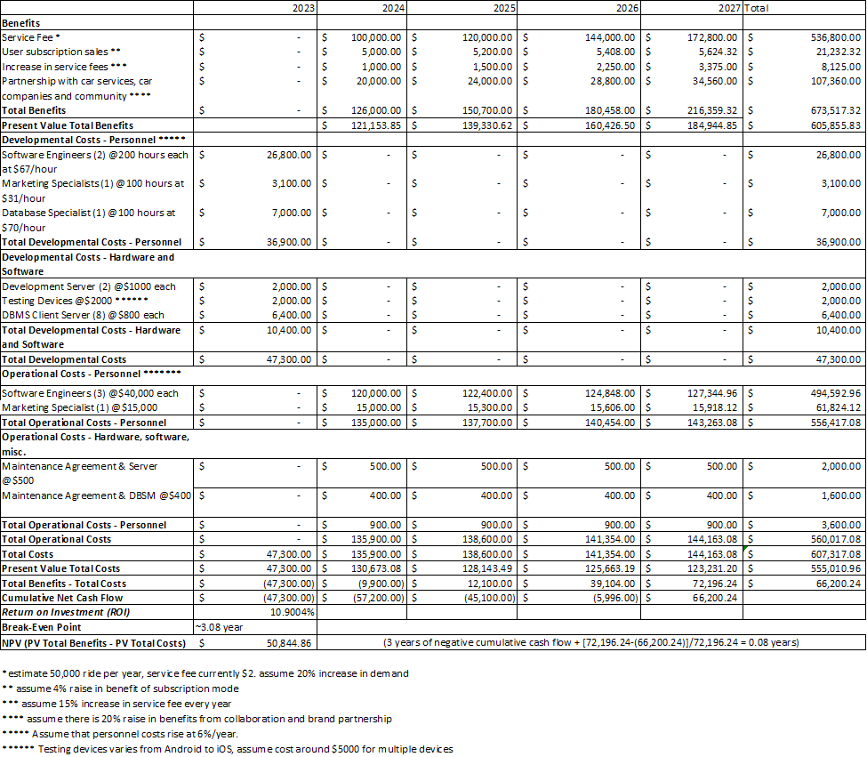

The Economic Feasibility Analysis shows that the project will result in a positive NPV of $50,844 over the next four years. Moreover, the return on investment (ROI) is at 10.9% with the break-even point after 3 years. Based on this analysis we will suggest the investor move forward with the project.

## Marketing Strategy

**Brand Positioning:**

* **Unique Selling Proposition (USP):** Embark on a ride-sharing adventure unlike any other, where affordability, dependability, and sustainability come together to form a community-driven voyage. Our app is about more than just moving you from one place to another; it's about making connections and creating a long-lasting, close-knit community. Join us in decreasing our carbon footprint while experiencing the warmth of a caring network.
* **Brand Story:** Our story is built on a dedication to both community and sustainability. Consider a ride-sharing business that not only connects destinations, but also people and the environment. Every journey is an opportunity to create relationships and contribute to a sustainable future, thanks to our eco-friendly fleet, affordable rides, and dedication to community support. We're not just moving forward as a group; we're moving forward as a community.

**Online Presence:**

* **Website Optimization:** Visit our user-friendly website for all things ride-sharing! Explore our services, discover our commitment to sustainability, and easily download our app for hassle-free commuting.
* **Social Media:** Join our vibrant community on Facebook, where we share exciting updates, promote local events, and connect with our riders. Follow us on Twitter for real-time news and quick interactions and check out our Instagram for a visual journey of our eco-friendly rides and engaged community. By establishing a strong LinkedIn presence, we can leverage the platform for brand awareness, industry networking, recruitment, and reinforcing our commitment to sustainability. Stay connected, stay informed – because we're more than just a ride, we're a community on the move!

**Content Marketing:**

* **Blog Posts:** Explore our blog for insightful posts on local happenings, community events, and travel tips. Learn how our ride-sharing app enhances your commuting experience while contributing to a sustainable and connected community.
* **Video Content:** Dive into our YouTube channel for visually appealing videos highlighting the features that set our ride-sharing app apart. From safety measures to firsthand community testimonials, our videos offer a glimpse into the unique journey we provide.
* **Influencer Collaboration:** Through the Instagram influencer strategies, we aim to create an immersive and visually appealing narrative, turning our community's everyday rides into a captivating and shareable experience.

**Voucher/Discount Creation:**

* **Community Discounts:** Provide discounted rides to certain communities with a valid ID, making it more affordable for them to commute to and from the location.
* **First Ride Discount:** Provide a significant discount on their first ride. This discount can be a fixed amount or a percentage of their total fare. For example, offer a "$10 off your first ride" promotion.
* **Frequent Rider Program:** Mention the possibility of joining a frequent rider program where users can accumulate points or rewards for every ride.
* **Local Partnerships:** Collaborate with local businesses, such as restaurants, theaters, or shopping centers, to create bundled discounts for mutual customers. For example, offer a discounted ride to a restaurant along with a meal voucher.
* **Referral Bonuses:** Encourage first-time users to refer friends to your app by offering them a bonus for each successful referral. This can extend your user base while rewarding your new customers.
* **Sustainable Transportation:** Promote eco-friendly rides by offering promo codes for rides taken with electric or hybrid vehicles.

**Partnerships and Collaborations:**

* **Local Businesses:** Join forces with local businesses! Our ride-sharing app proudly collaborates with neighborhood favorites. Use our service, unlock exclusive discounts at partner establishments, and experience the best your community has to offer.
* **Community Events:** By actively engaging in community events, we position ourselves not just as a service provider but as an integral part of the community, fostering genuine connections with event attendees.

**User Reviews and Testimonials:**

* **Encourage Feedback**: Your ride, your voice! Share your thoughts on your latest journey with us. Open the app and leave your feedback—it is how we make your experience even better.
* **User Stories**: Your stories, our inspiration! Discover how Joyntway has transformed commutes and connected communities through our user stories. Visit our website to read about the real-life experiences shared by our incredible riders.

**Purchased User Data:**

* We will incorporate purchased data from Google, Facebook, and LinkedIn to target our marketing efforts. We will focus on finding users that are starting new education programs, jobs, or commute routes that would benefit from being a passenger. By using this data, we will create data driven advertisements and incentives that offer direct benefits to populations that do not have a strong network in each area.

# Risk Assessment Matrix

We have created a risk assessment matrix for the evaluation of potential hazards and threats associated with the application’s operations. It consists of two main categories application development risks and operation risks. It also encompasses a range of factors such as data security, user safety and technical glitches. The matrix assesses risks based on their likelihood and degree of impact of the event of occurrence. Categorizing them into different levels of severity. For instance, data breaches or cyber-attack pose a substantial risk due to their likelihood and potential for severe impact on user privacy. Similarly, inadequate background checks for drivers or lack of safety protocols can also be considered as critical risks affecting user safety. By using this matrix, JoyntWay can systematically identify, prioritize, and address these risks, implementing preventive measures, contingency plans, and robust security protocols to mitigate and manage potential threats effectively. (Refer to the table below).

## Future Recommendations

The JoyntWay application envisions several future enhancements aimed at revolutionizing the user experience. These include bolstering safety measures through real-time tracking, verification protocols for both drivers and passengers, emergency buttons, and trip-sharing functionalities. Additionally, the platform seeks to optimize travel routes dynamically by employing sophisticated algorithms that adapt to real-time traffic conditions, user preferences, and multiple pick-up/drop-off requests. Integration with various transportation modes, environmental impact awareness promoting eco-friendly practices, and incentivization programs for users through rewards, referrals, and gamification are also on the horizon. Moreover, the implementation of advanced AI-based matching algorithms aims to elevate ride-matching efficiency by considering similar locations and references, promising enhanced convenience and effectiveness for users.

|  |  |  |  |  |  |  |  |
| --- | --- | --- | --- | --- | --- | --- | --- |
|  | **Risk Assessment Matrix** | | | | | | |
| **Categories** | **RISK** | **IMPACT** | **LIKELIHOOD OF OCCURANCE(L,M,H)** | **DEGREE OF IMPACT (L, M, H)** | **ACTION TRIGGER** | **RESPONSIBILITY** | **RESPONSE PLAN** |
| Application Development Risk | Unfamiliarity with the tool that uses for developing the application | Staffs may face some challenges developing the application, that could lead to delay in development process | M | M | A staff show/express confusion about the tools using for development and asking for guide. | Manager(check staffs familarity) and staffs | The application developer will familiarize development staff with the tool that they need to use, Will provide help desks and documents for staff. Have one pointer person to help troubleshoot if staffs face any challenges due to the software. |
| Application Development Risk | Technical glitch during the usage of mobile app | Users may not able to access the application for long period of time | M | M | Sometimes if the user wanted to book the ride but it didn't show in their interface and the ride got booked later. | Application and staffs | Shall conduct test and drills to evaluate the effectiveness of the application. |
| Application Development Risk | Exposure to security threats, data breaches, or hacking due to weak code security. | Exposing user's personal information such as name, phone number and address. | M | H | If a scammer wants to hack the systems | Programmer, Software developer | Will insure writing secure codes and implementing security measures. |
| Application Development Risk | Technology obsolescence | Rapid change in technology can lead to the potential changes that need to be done in the app. | H | H | When customers are accustomed to using the application in a particular manner and are suddenly confronted with new features, they might feel the need to familiarize themselves with these updates in order to continue using the application effectively. | Software Engineer | Shall establish a team to monitor the emerging trends of technology. |
| Operation Risk | Inclement weather (flash floods, tornado, snow storms, etc) | Drivers may not be able to safely provide transportation and be willing to risk their vehicle during a weather event. | L | M | severe weather alerts from local weather agencies | Staff and the developed application | Application will provide alerts regarding extreme weather situations and encourage safe behavoirs |
| Operation Risk | Fluctuating and rising transporation costs (gas, tolls, car maintence, insurance fees, registration fees, auto loan interest rates, etc) | Drivers may not be able to afford to keep up with rising costs associated with being a car owner | L | L | Increase in county's average gas price inclurease of 15% | Application and staffs | Application will prompt the users to recalculate an appropriate price, provide promotions and benefits for drivers via partnerships with other companies. |
| Operation Risk | Insufficient driver background check | Driver may provide wrong information about self or the vehicle | M | H | temporarily suspending the driver's account, pending a thorough re-evaluation of their credentials. | Safety response team | Will create an alert system can be implemented to notify relevant personnel or authorities responsible for conducting background checks, ensuring swift resolution and preventing drivers with inadequate verifications from accepting ride requests until the issue is resolved satisfactorily. |
| Operation Risk | Price war with competitors | Price wars can erode profit margins because of engagement in price cutting. | M | M | Other similar applications have a better pricing than the application. | Project Manger | Will develop a pricing strategy that leads to long term profitability rather than engaging in price wars |
| Operation Risk | Accidents during rides | The user may be hesitant to use the application. | L | H | There may be infortunate incidents like human error or if the driver falls asleep due to exhaustion and there is a car accident. | Safety response team | Will develop and enforce strict protocols and guidelines for drivers and passengers. |
| Operation Risk | Driver behavior issues | The user may feel uncomfortable and may to less motivated to use the application | M | M | Some drivers may be rude to the passangers travelling with them. | Safety response team | Shall encourage user to give feedback on the rides and also on the drivers behavior. |
| Operation Risk | Payment processing errors | Sometimes there might be some payment processing errors such as the payment would processed but didn't show up on the drivers interface. | L | L | If the payment didn't show up in the driver's screen and it has the money has been deducted from the user's account | Customer Service Manager | Will invest on a more robust payment technology. |

## Appendices:

### Validation Method

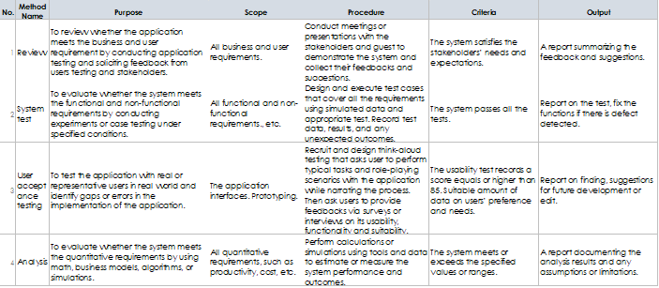

### Verification Method

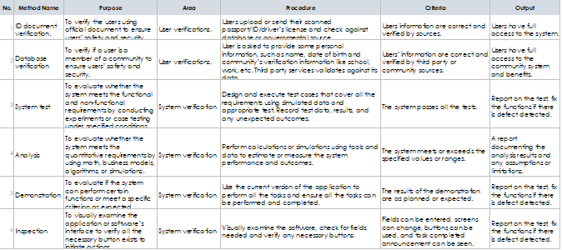

### 

### **WPI JoyntWay Marketing Flyer**

### Joyntway Marketing Wallet Flyer

Appendix A

Future Recommendations

The JoyntWay application envisions several future enhancements aimed at revolutionizing the user experience. These include bolstering safety measures through real-time tracking, verification protocols for both drivers and passengers, emergency buttons, and trip-sharing functionalities. Additionally, the platform seeks to optimize travel routes dynamically by employing sophisticated algorithms that adapt to real-time traffic conditions, user preferences, and multiple pick-up/drop-off requests. Integration with various transportation modes, environmental impact awareness promoting eco-friendly practices, and incentivization programs for users through rewards, referrals, and gamification are also on the horizon. Moreover, the implementation of advanced AI-based matching algorithms aims to elevate ride-matching efficiency by considering similar locations and references, promising enhanced convenience and effectiveness for users.